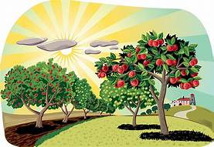
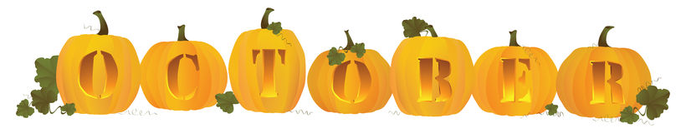
Important Dates
Friday October 15th - Early Release
Wednesday October 20th – Vision and Hearing screening.
What we are Learning
Preschoolers are continuing to learn about the Fall Season.
Kindergarten is learning the letter “W” and they are beginning to learn about addition strategies.
Second grade is learning addition strategies.
Third grade is learning about elapsed of time

Unified Arts
Music - Learning steady beats.
Spanish - Learning numbers.
Library - Book orders.
Art - Finishing Murakami Flowers.
Guidance - Learning about Respect
Health - Learning about Safety
Physical Education - Learning soccer skills
Highlights
This week grades K-3 has learned about bully prevention. On Wednesday, the students had the evacuation drill and their field trip to Windy Ridge Apple Orchard. The students were very excited. VINS came and taught Preschool about weather and taught K-3 about wind speeds and they used anemometers, which is a tool to measure wind speeds.
October 11th - October 15th
https://landaffblueschool.wixsite.com/home

