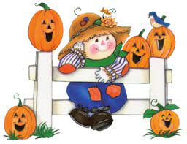
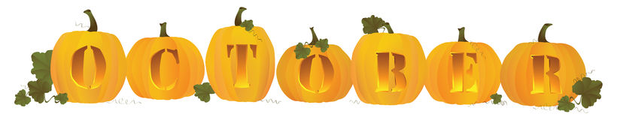
Important Dates

Friday October 29th - Halloween Party
What we are Learning
Preschoolers are learning about skeletons and reading Halloween books.
Kindergarten is learning the letter “R”, shapes, and rhymes. Kindergarten started writing in their journals.
Second grade is learning Addition and subtraction strategies, and started to learn about the writing process.
Third grade is learning multiplication and two step word problems. Third grade also started the writing process.
October 18th - October 22nd
https://landaffblueschool.wixsite.com/home
Highlights
This week the Blue School had a visitor from Grafton County Department of Corrections. Rachel Harness, came in and taught them about the Operation Impact Program! Grades K-3 learned about making good choices in and out of the classroom. All grades had a hearing and vision screening on Wednesday. We just got our Usborne Book Orders, enjoy reading with your child!

Unified Arts
Music - Learning/making rain sticks.
Spanish - No class this week.
Library - Learning about book reviews and reading hunting books.
Art - Making and painting leaves.
Guidance - Learning about Bullying Prevention.
Health - Learning about staying safe and not talking to strangers.
Physical Education - Learning soccer skills

